Exercise 15
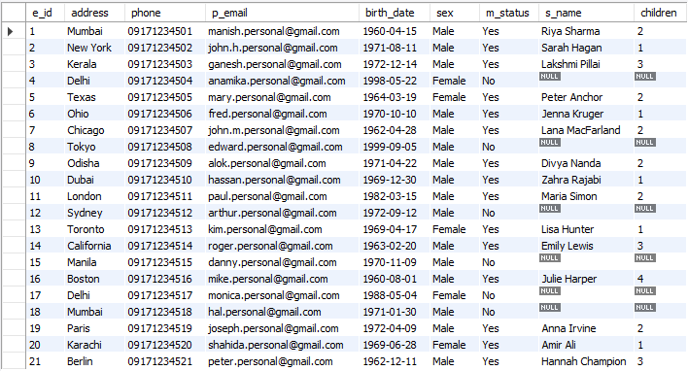
- SELECT e_id, birth_date FROM employee_personalinfo WHERE birth_date < '1965-01-01';
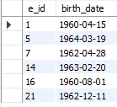
- SELECT e_id, birth_date FROM employee_personalinfo WHERE birth_date BETWEEN '1970-01-01' AND '1972-12-31';
